**Java 8 Features**

**Date 19/02/2021**

**Exercise**

**Google doc link:** [**https://docs.google.com/document/d/10bQoZPtM5YcPgKwJKDG4juPlYW6ted2gz-jkVAFGw4Q/edit?usp=sharing**](https://docs.google.com/document/d/10bQoZPtM5YcPgKwJKDG4juPlYW6ted2gz-jkVAFGw4Q/edit?usp=sharing)

* **Write the following a functional interface and implement it using lambda:**
  + **(1) First number is greater than second number or not Parameter (int ,int ) Return boolean**
  + **(2) Increment the number by 1 and return incremented value Parameter (int) Return int**
  + **(3) Concatination of 2 string Parameter (String , String ) Return (String)**
  + **(4) Convert a string to uppercase and return . Parameter (String) Return (String)**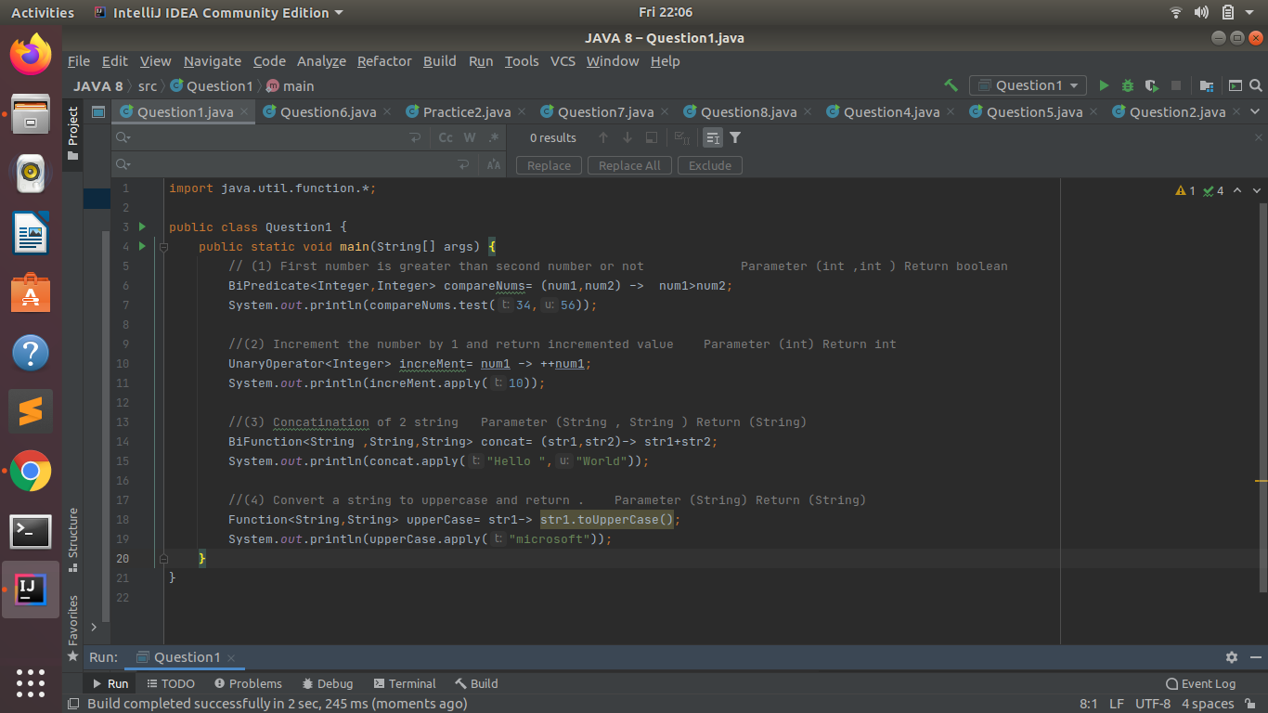

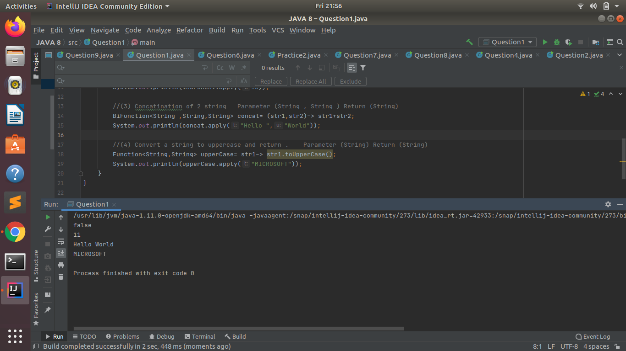

* **Create a functional interface whose method takes 2 integers and return one integer.**

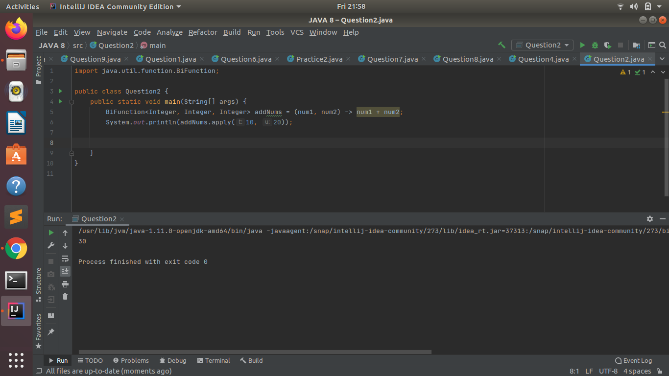

* **Using (instance) Method reference create and apply add and subtract method and using (Static) Method reference create and apply multiplication method for the functional interface created.**

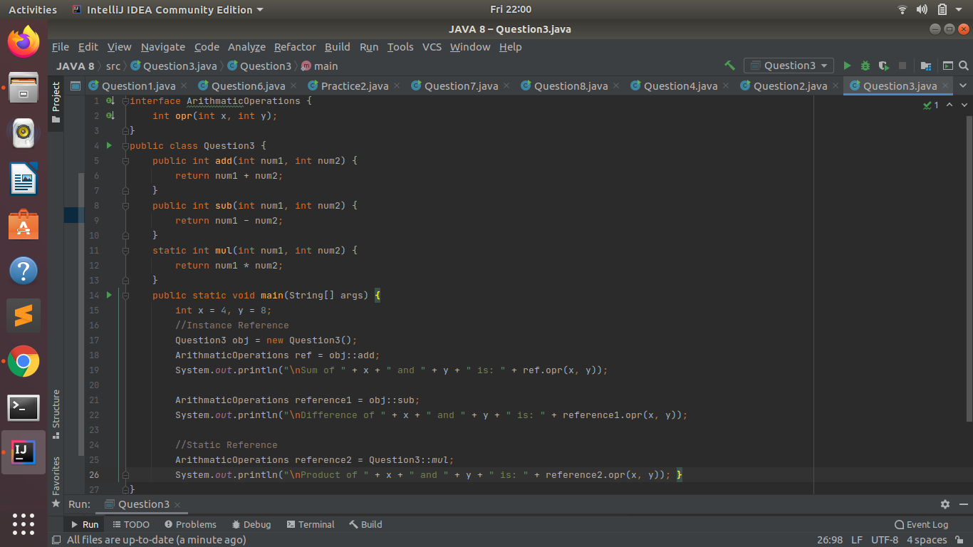

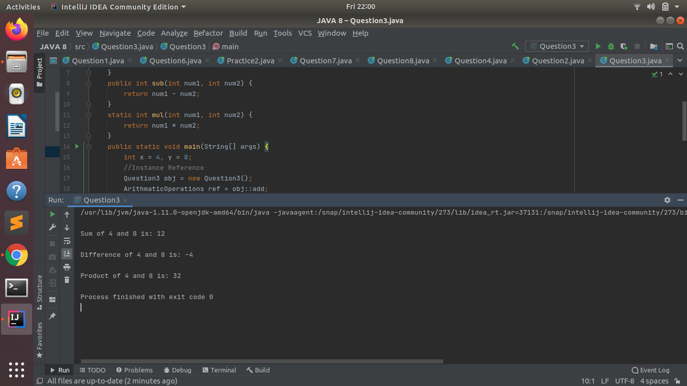

* **Create an Employee Class with instance variables (String) name, (Integer)age, (String)city and get the instance of the Class using constructor reference**

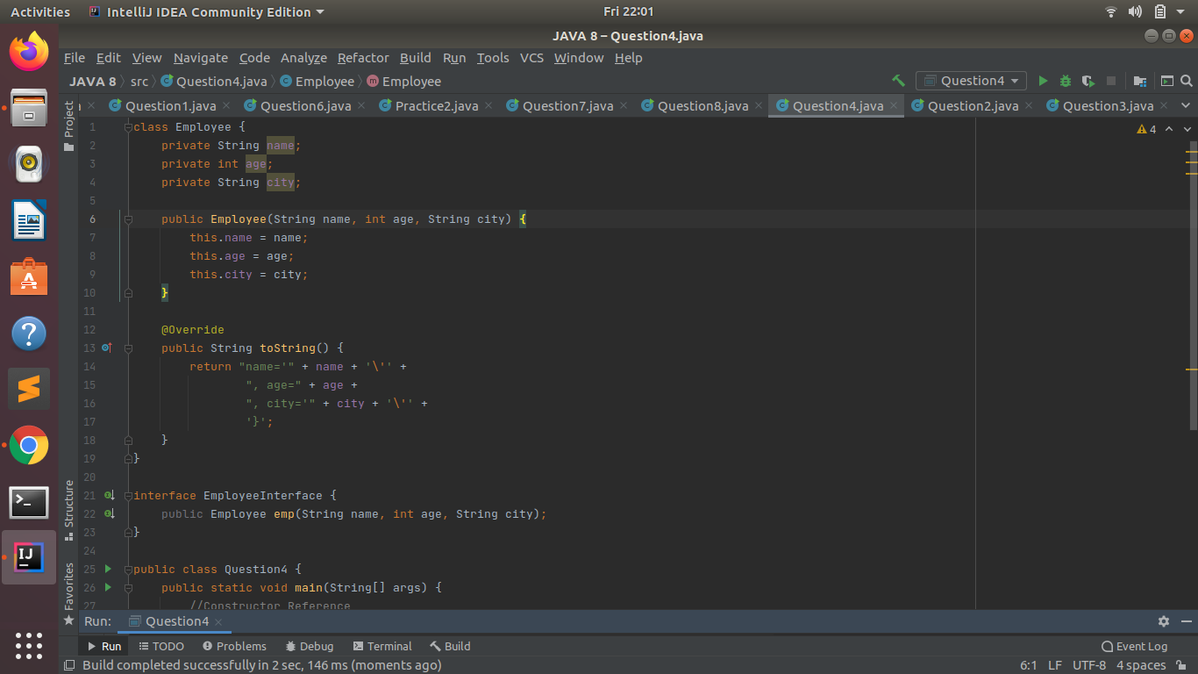

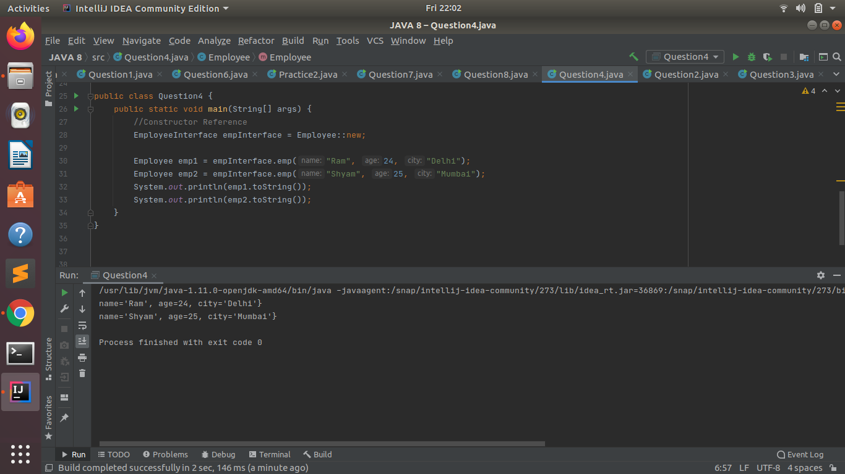

* **Implement following functional interfaces from java.util.function using lambdas:**
  + **(1) Consumer**
  + **(2) Supplier**
  + **(3) Predicate**
  + **(4) Function**

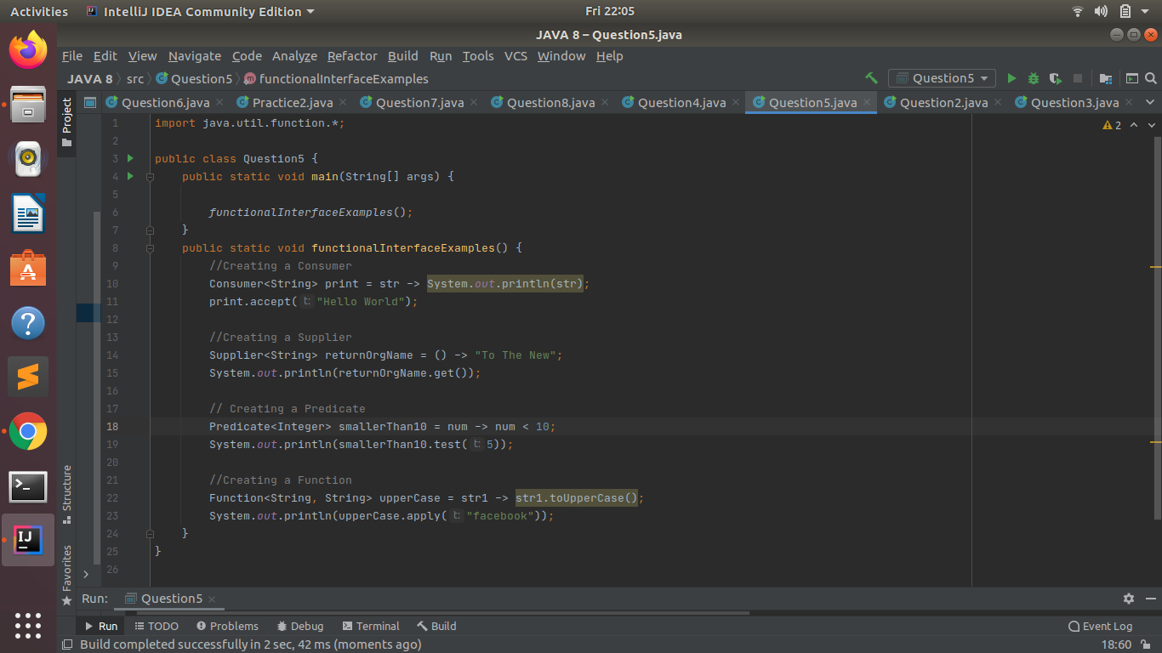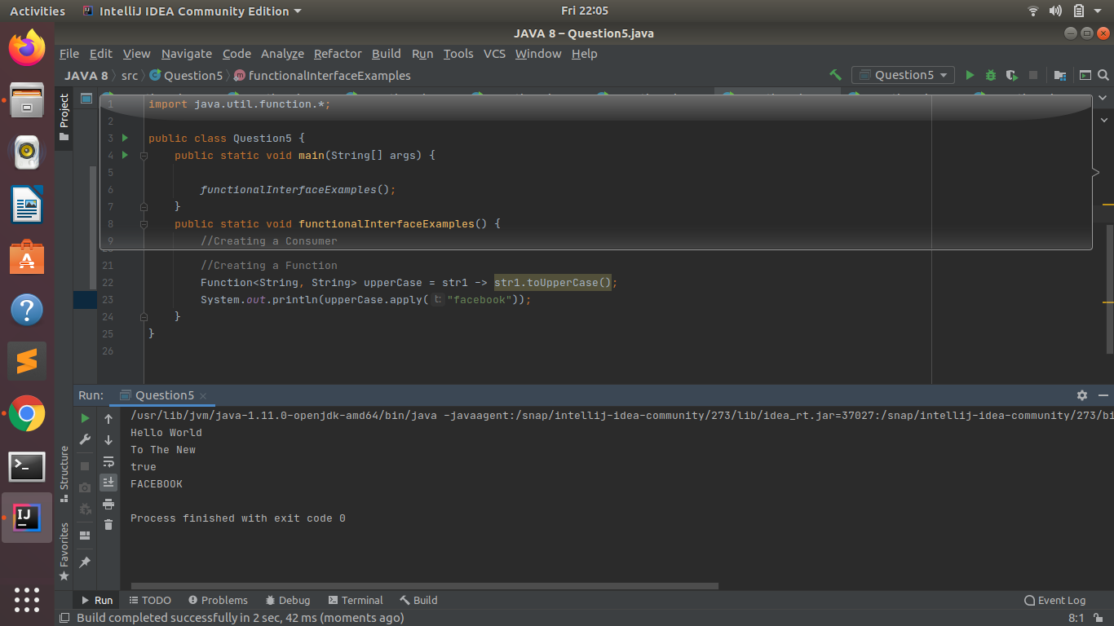

* **Create and access default and static method of an interface.**

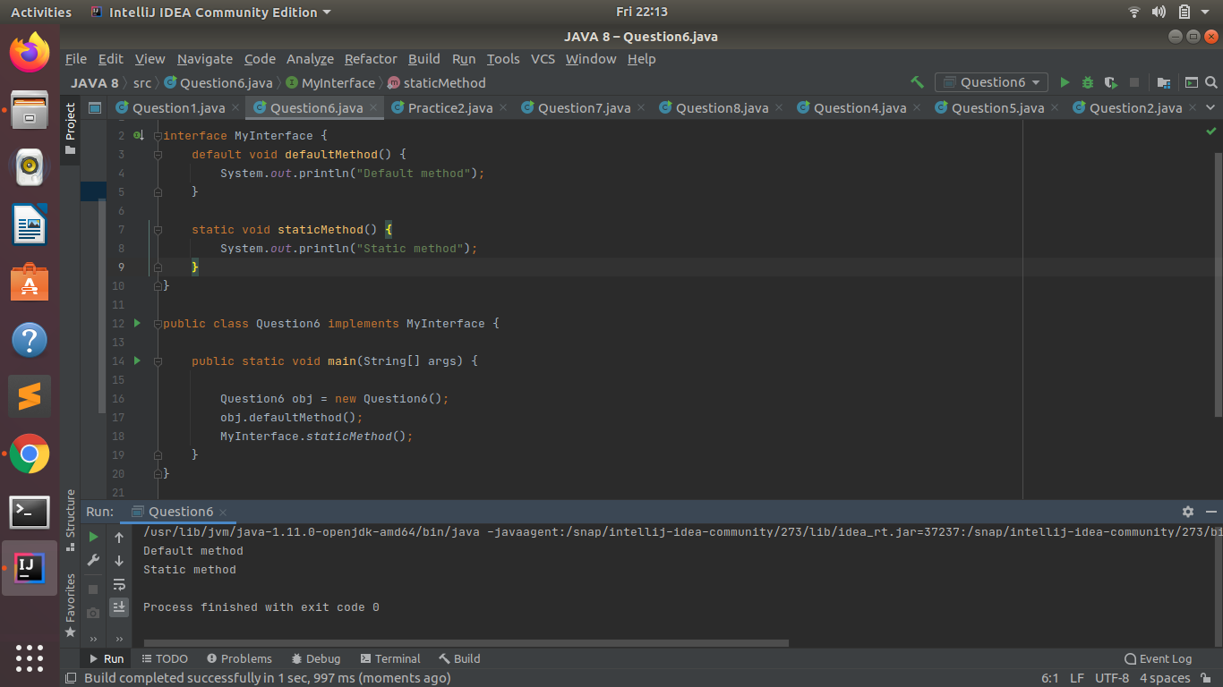

* **Override the default method of the interface.**

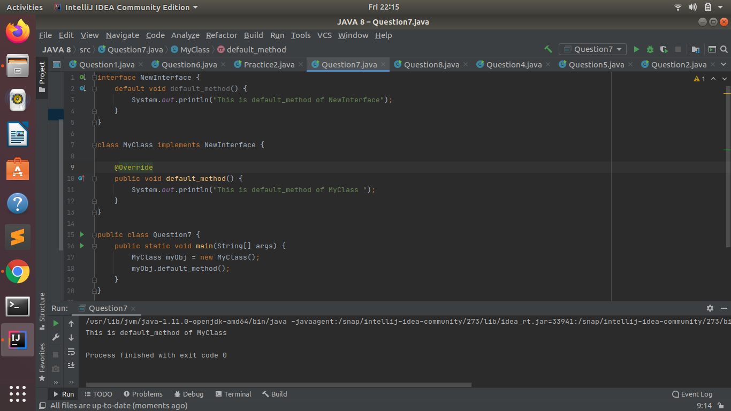

* **Implement multiple inheritance with default method inside interface.**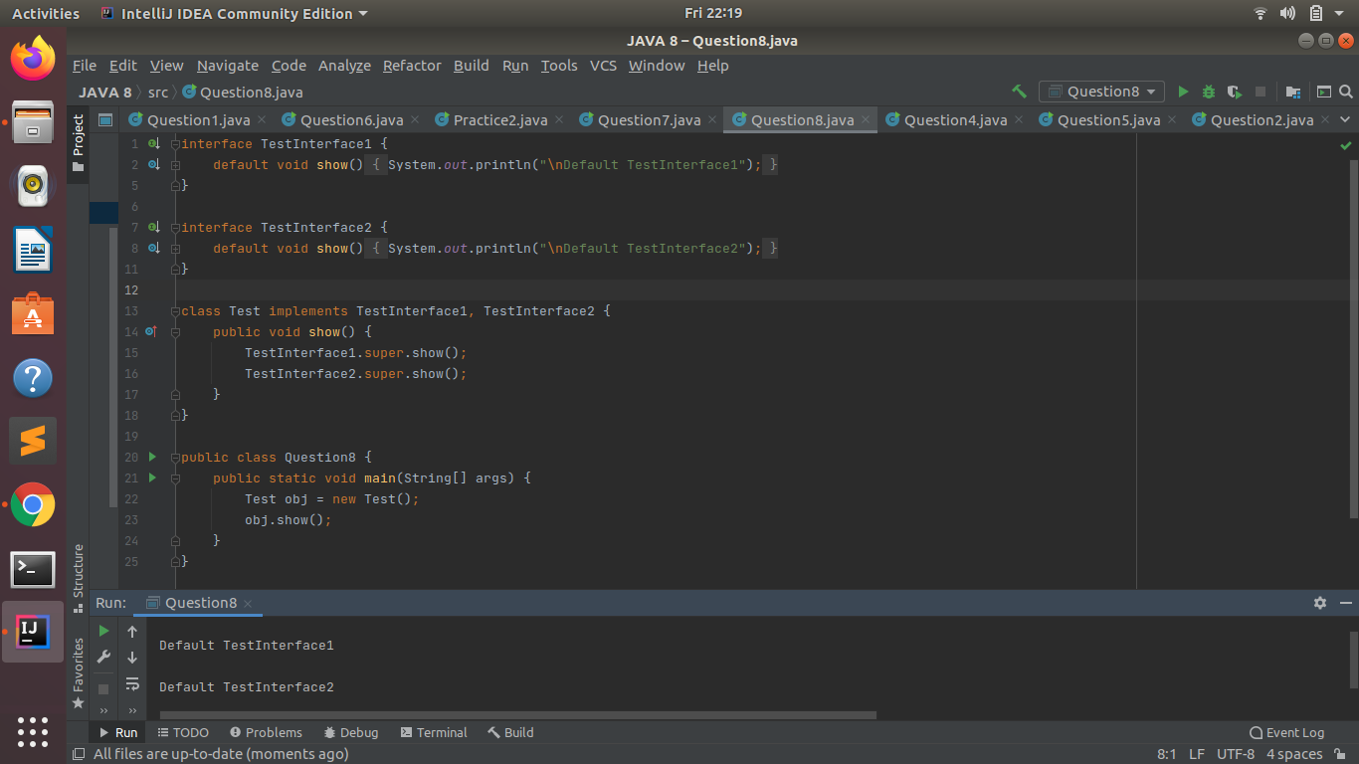
* **Collect all the even numbers from an integer list.**

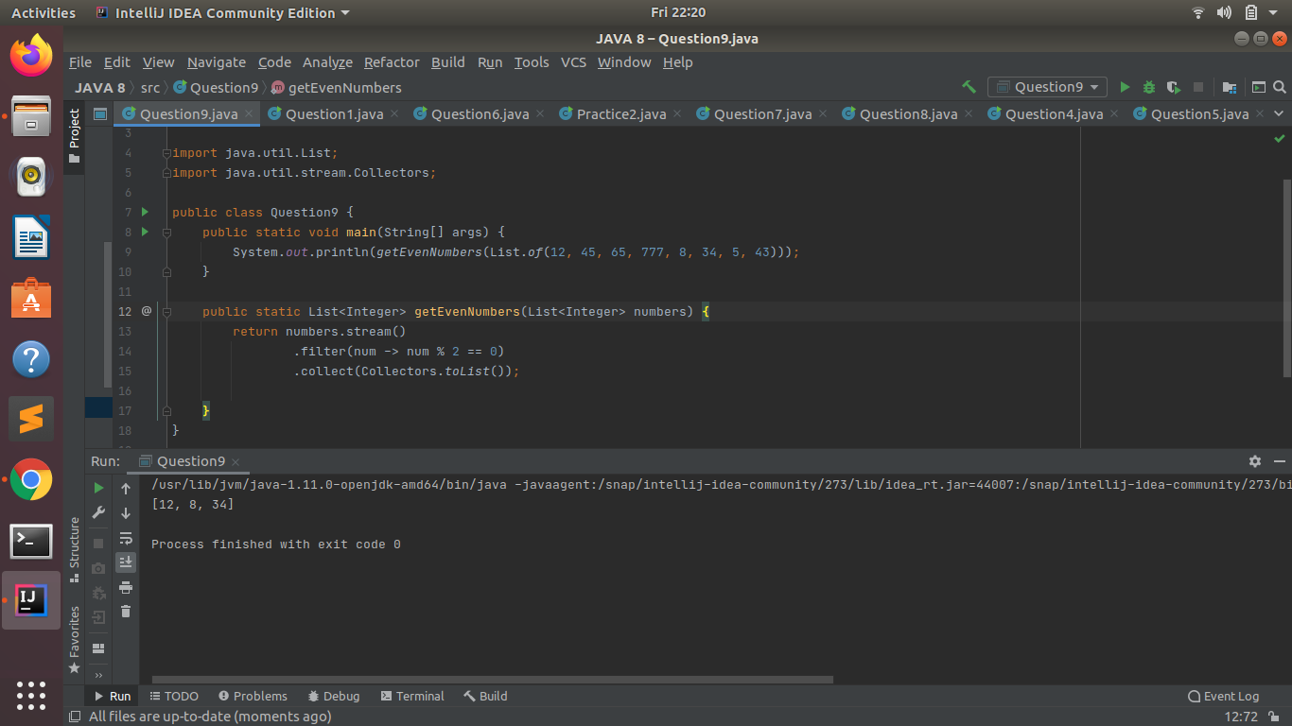

* **Sum all the numbers greater than 5 in the integer list.**

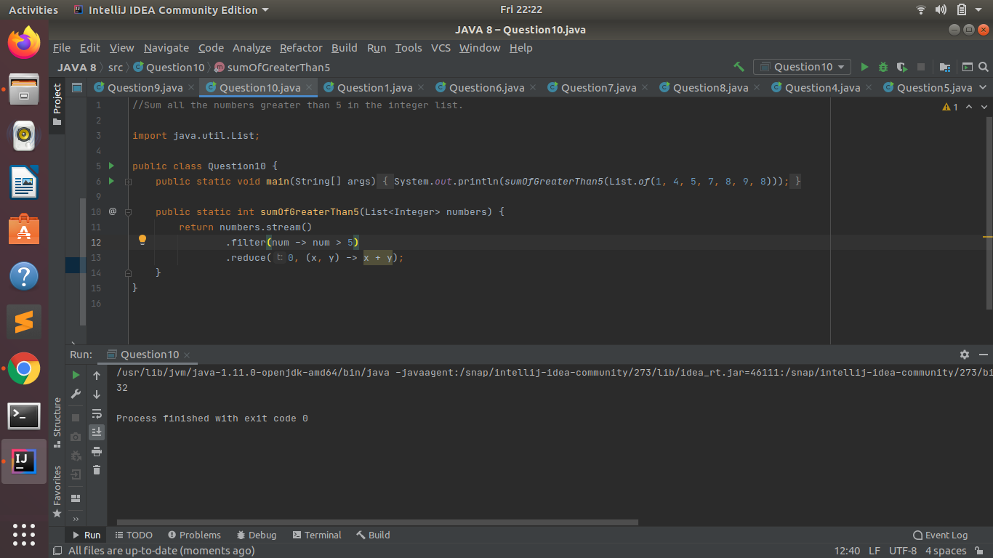

* **Find average of the number inside integer list after doubling it.**

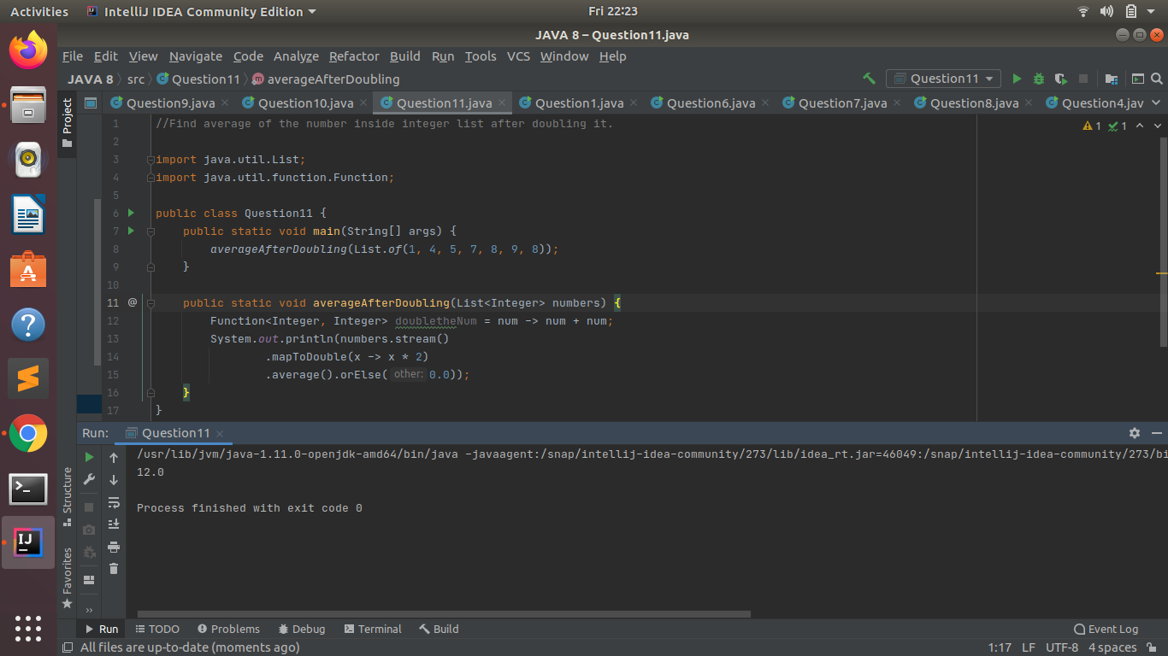

* **Find the first even number in the integer list which is greater than 3.**